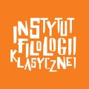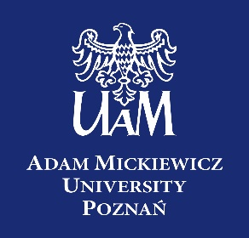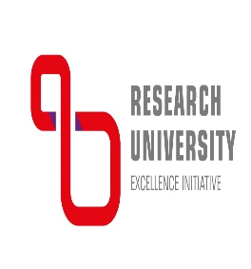

On Tyranny and Democracy:
Dictators and Democrats in the Ancient Greek World

‘There is nothing more unjust among mortals nor more bloodthirsty than tyranny.’ This is a view expressed by the Greek historian Herodotus of Halicarnassus (V.92a1), who was writing in the second half of the fifth century BC. It encapsulates well the widespread fear and abhorrence of the form of regime the Greeks called tyrannis, which may be translated as tyranny or dictatorship. The Greeks were the first to name and study this type of rule. They were also the first to think seriously about the threat posed by unlimited autocracy and their cities were the first polities to develop law codes that limited the powers of magistrates.

In this same period, the city of Athens, among others, was developing a form of constitution that would become known as demokratia, or democracy. Popular governance and the rule of law are often presented as the most important political legacy of classical Greece (c. 500-300 BC), and Athens in particular. Yet no understanding of democracy is complete without an understanding of tyranny. Democracy can be seen as a response to tyranny, while tyrants often begin as radical democrats or demagogues.

A major focus will be on how research in modern Political Science can illuminate studies on ancient politics. In turn, a broader aim of this series is to suggest ways in which the experience of the ancient Greeks can inform our understanding and approach to dictatorships in the modern world. In the twenty-first century, personalist dictatorships are increasing in number but their methods and motivations are often misunderstood in democratic states by the public and policy-makers alike. This lecture series, in exploring the views of the first democrats on tyranny, will appeal to anyone interested in democracy, dictatorship and political theory in general.
Autumn semester

Edmund Stewart (University of Nottingham): ‘How to spot a tyrant’ – 4th of November, Thursday, 19h00 CET/18h00 GMT/20.00 EET

Edward Harris (University of Durham): ‘How do laws and institutions affect the survival of democracy and tyranny?’ – 17th of November, Wednesday, 19h00 CET/18h00 GMT/20.00 EET)

James Kierstead (Victoria University of Wellington): ‘How Fine a Thing’: Isēgoria, State Performance, and Democratic Dignity – 7th of December, Tuesday, 9h00 CET/08.00GMT/21h00 NZDT

Xavier Marquez (Victoria University of Wellington) ‘A comparative study: how do modern dictatorships work? Studying modern authoritarian regimes alongside ancient political theory.’ – 11th of January, Tuesday, 9h00 CET/08.00GMT/21h00 NZDT

Panel discussion/meeting with students – 25^{th of} January, Tuesday, 9h00 CET/8h00 BST/10hEET/21h00 NZST

Spring semester (dates and times to be confirmed)

Mirko Canevaro (University of Edinburgh): ‘What is it like to live under a tyrant? Esteem, honour, and respect in tyrannical regimes’. – 2nd of March, Wednesday, 19h00 CET/18h00 GMT

Elodie Paillard (University of Basel): ‘Why did Tyrants Sponsor Theatre?’ – 6th of April, Wednesday, 19h00 CEST/18h00BST

Andrew Hanssen/Robert Fleck (Clemson University): ‘Transitioning from Tyranny to Democracy (and back again?), What Can We Learn by Comparing the Modern World to Ancient Greece?’ – 4thof May, Wednesday, 19h00 CEST/ 18h00 BST/ 13h00 EDT

Josiah Ober (Stanford University): ‘What can Political Science tell us about ancient tyranny and ancient democracy?’ – 1st of June, Wednesday, 19h00 CEST/18h00 BST/10h00 PDT

Panel discussion/meeting with students – 15thof June, Wednesday, 19h00 CEST/18h00BST/10h00 PDT

