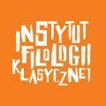
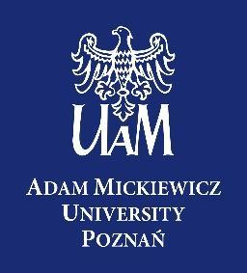

Between Jesuit College and Port-Royal:
Classical Culture and Religious Controversy in the 17th-Century France
25–28 March 2023

Saturday, 25 March, Wieniawskiego 3

13.00 Lecture:
Michael Asmus (Stony Brook University, New York), Music by the French Clavecinistes
Concert:
Louis Couperin (c. 1626–1661): Suite de pièces in a
Jacques Champion de Chambonnières (1601–1672): Suite de pièces in d from Livre première (1670)
Michael Asmus, harpsichord

Sunday, 26 March, Wieniawskiego 3

13.00 Marc-Antoine Charpentier, Leçons de Ténèbres (H. 120-122) – open rehearsal

Monday, 27 March, Salon Mickiewicza, Collegium Maius

16.00 – 17.30 Opening of the conference
Session 1: Jansenism: Theology and Culture
Wim François (KU Leuven), Augustinianism and Jansenism in Seventeenth-Century France
Mateusz Stróżynski (AMU), The Gods of the Philosophers and Their Burning Hearts: Augustine and Pascal

18.00 Concert (Lubrański Hall, Collegium Minus)
Marc-Antoine Charpentier, Leçon de Ténèbres (H.120-122).

Mateusz Stróżyński – baritone
Olga Musiał-Kurzawska – flute traverso
Debora Kramarek – violin
Paweł Drozdowski – viola
Stanisław Stanicki – cello
Michael Asmus – harpsichord

Tuesday, 28 March, Salon Mickiewicza, Collegium Maius

9.00-10.30 Session 2: Rhetoric, Theology, and Music
Michael Asmus (Stony Brook University, New York), Les Leçons de Ténèbres: Marc-Antoine Charpentier’s Holy Week in Louis XIV’s France
Thierry Favier (University of Poitiers), The French Leçons de Ténèbres: Moral Theology and Social Thinking in the Jesuit-Jansenist Controversy

10.30 Coffee break

11.00-12.30 Session 3: Jesuits and Classical Culture
Jaspreet Singh Boparai (Independent Scholar), Poussin, Corneille, Seneca, and the Jesuit College at Rouen
Michał Bajer (University of Szczecin), Le décodage savant: Le retour aux sources érudites dans les traductions polonaises de Racine (1700–1830)

12.30 Lunch break

16.00-17.30 Session 4: Blaise Pascal and the Jesuits
Robert Aleksander Maryks (AMU), Pascal’s Provincial Letters and the Suppression of the Society of Jesus in France

Closing remarks

